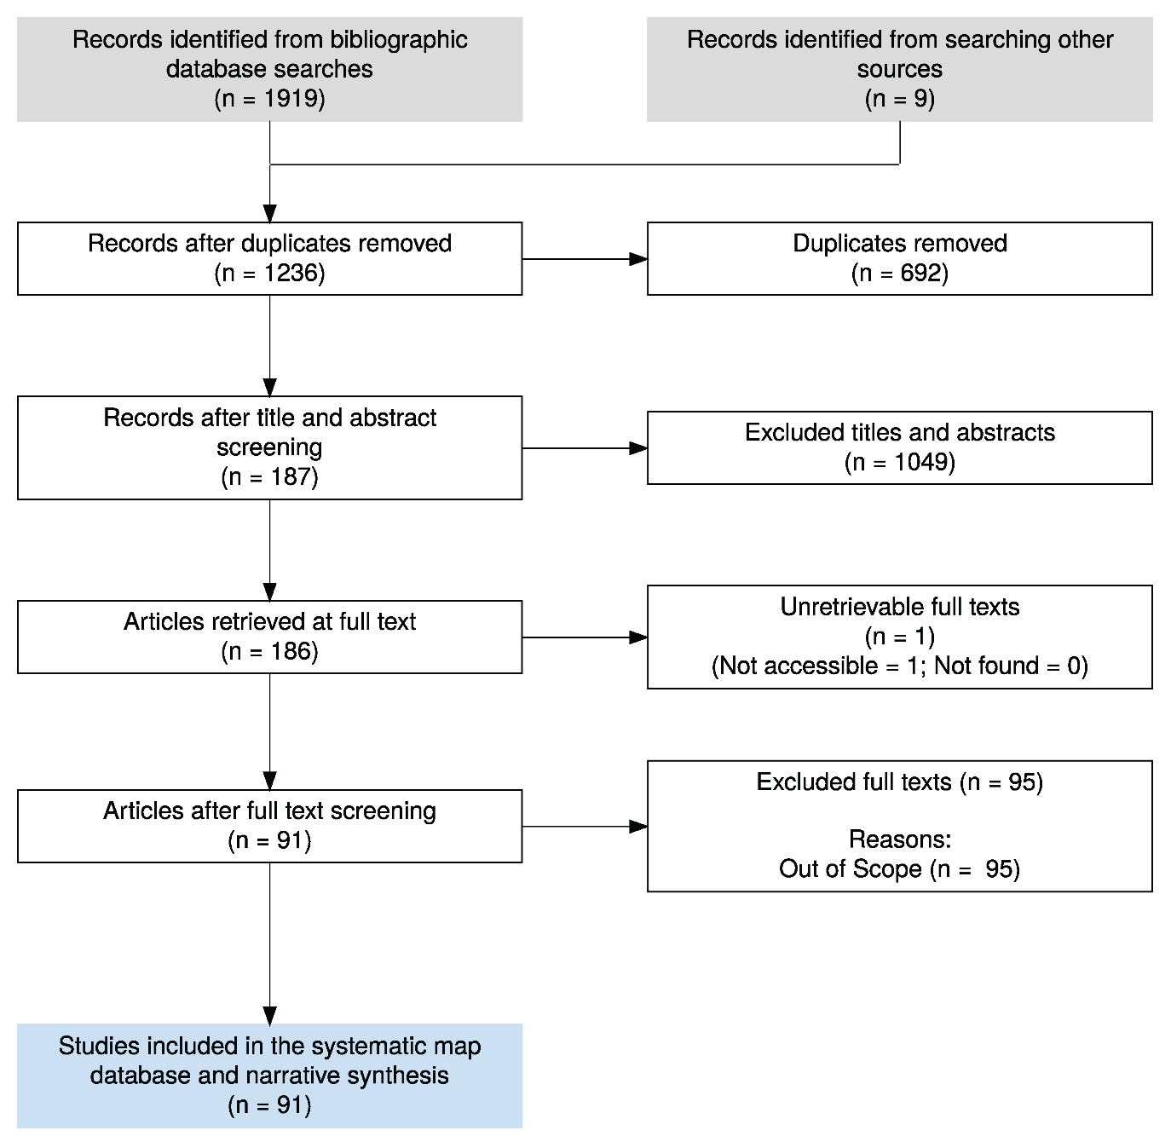

Figure 1 Flow diagram of this systematic map, detailing the process of removal literature per stage. Created with ROSES reporting flow diagram tool.